Step 1 :- Download a code from github to desktop

→ Login to our github account

→ Create a one of the new repository with name Hello world

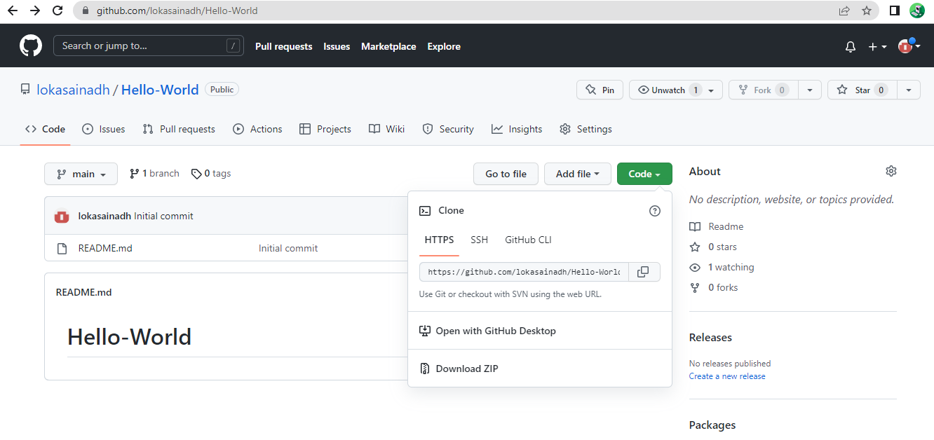

→ In that repository go to code and select open with github desktop and select windows , navigate to the local path where you want to clone the local repository.

